Biz Perf Analyzer
Go to https://www.airtable.com/ and create an airtable account.
Click this link and click “Copy Base” to duplicate the base in to your account.
https://airtable.com/appAEjnrwagzeIs8F/shrGrljZqzKGhH7n9
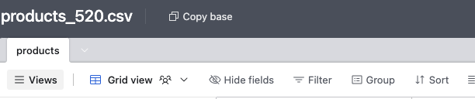

After account creation, start at home screen, click your profile > Builder Hub > Personal access tokens > create token
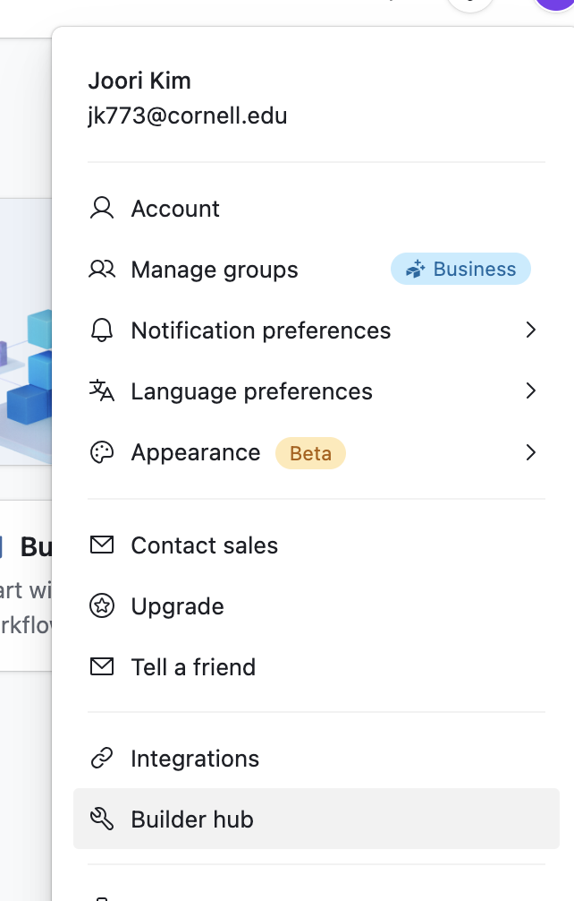

Code Node

USE THIS:
// ✅ Process all Airtable records into a clean JSON array
const cleanedData = $input.all().map(item => {
const record = item.json;

return {
id: record.id,
cost: parseFloat(record.cost),
category: record.category,
name: record.name,
brand: record.brand,
retail_price: parseFloat(record.retail_price),
profit_margin: parseFloat(record.retail_price) - parseFloat(record.cost),
department: record.department,
sku: record.sku,
distribution_center_id: record.distribution_center_id
};
});

// ✅ Return a single item with the array inside `records`
return [
{
json: {
records: cleanedData
}
}
];

AI Agent node
PROMPT
You are a meticulous product data analyst. Please analyze this exact product catalog data and create a structured, data-driven report with deeper insights.
The dataset contains 520 products**.
Here is the detailed product dataset:

{{ $json.records.map((item, index) => `${index + 1}. ${item.name}
- Category: ${item.category}
- Department: ${item.department}
- Brand: ${item.brand}
- SKU: ${item.sku}
- Cost: $${item.cost}
- Retail Price: $${item.retail_price}
- Profit Margin: $${(item.retail_price - item.cost).toFixed(2)}`).join('\n\n') }}

###Please use this exact structure for your response:
1. **Executive Summary**
- Provide 2–3 high-level findings about pricing, margins, or trends.
- Mention any interesting overall pattern in the dataset.

2. **Key Metrics**
- Total number of products
- Average profit margin (calculate it)
- Highest and lowest profit margin

3. **Top Brands**
- List top 3 brands by number of products
- Provide counts for each

4. **Retail Pricing by Category**
- Category with highest average retail price
- Category with lowest average retail price
- Profit Margins by Department
- Department with highest average profit margin
- Department with lowest average profit margin

5.**Outlier Products**
- Identify 3 products with very high profit margins
- Identify 3 products with very low or negative margins

Use **bullet points or tables where appropriate.
Ensure insights are easy to follow. **Store the entire dataset in memory** for follow-up queries.

Open AI Message a model node

PROMPT FOR EMAIL FORMATTING

You are an AI report formatter. Convert the following plain-text report into a professionally formatted HTML email.

Requirements:
- Start with: "Hey Everyone<br><br>Good morning! Hope you had an amazing weekend.<br>Sharing the weekly report for the last whole week."
- Use <h2> or <h3> for section headers.
- Use <strong> for key labels and values.
- Use <p> for paragraphs and <ul>/<ol> for lists where appropriate.
- Use tables (<table>, <tr>, <th>, <td>) for structured data like brand counts or metrics.
- Highlight important metrics using <blockquote> or <div> with subtle styling.
- At the end, include this signature:

<br><br>Thanks,<br>Regards,<br><strong>Utkarsh</strong><br>Product Manager<br>InterviewKickstart

- End with this note, in bold:

<br><br><strong>Note:</strong> Also just mention this report is generated for demo purposes via Automated workflow on n8n Low/ No Code Tool.

Do not include ```html or triple backticks anywhere. The output should be a valid HTML snippet that can be pasted into an n8n email node.

Here is the content to format:
{{ $json.output }}

Questions:

Amandeep Amandeep 2:37 PM
What is the benefits of making 521 items into 1?

Srikumar Vaitinadin 2:45 PM
+1 to this question,

Srikumar Vaitinadin 3:08 PM
Dont we need an Email tool to send the report?

Rammohan Penchala 3:10 PM
can you please show the simple memory settings again?

Sanjay penmetsa 3:22 PM
Why are we using Memory? Is it mandatory for this workflow?

Sanjay penmetsa 3:24 PM
Save the workflow and refersh the page. Then click on execute

Amandeep Amandeep 3:27 PM
My AI agent output already seems to be well formated

Malangan Sirjoon 3:27 PM
sorry missed, what action should i choose?

Sanjay penmetsa 3:28 PM
OpenAI and Message a model

Sphoorti Patil 3:31 PM
How can i enable the logs and AI Agent and Output window like Samwel has ?

Sphoorti Patil 3:39 PM
i found it . Thx

Abhinay Abhinay 3:32 PM
Hey by the way 4.1 mini ran the whole thing

Joey Mari 3:37 PM
When creating a credential on gmail. I did not see connect using Google via (OAuth2).

Janhavi Giri 3:38 PM
I got this error " Bad request - please check your parameters
This model's maximum context length is 128000 tokens. However, your messages resulted in 141947 tokens. Please reduce the length of the messages." what was the proposed fix? can you please share?

Malangan Sirjoon 3:40 PM
Go to search records and disable return all and add Limit 100. Save and execute again

Janhavi Giri 3:41 PM
worked! thank you!

Sanjay penmetsa 3:39 PM
Wow. This workflow example directely effects my Job. :)

Erik Mace 3:39 PM
how do we trust this data and analysis? Hallucinations?
your data looks quite different than mine, both of us using 100 entries from the database.

Deepanshu Sandhuria 3:39 PM
What is role of memory here?

Prashanth Srinivasan 3:40 PM
what was the entry for the expression when sending the email

Erik Mace 3:43 PM
We could just drag/drop the "content" box from the left side "input"... drop that in the Message field.
this resulted in Message field: {{ $json.message.content }}

ANUPREET PANDHER 3:42 PM
Since the AI response is probablistic, how do we ensure that a standard report is sent everytime? What would be a good practice here? Should be add the format explictly in prompt or can be use some other tool that provides format to the workflow step right before sending email?

Kunjal Rathod 3:50 PM
+1

ANUPREET PANDHER 3:48 PM
I also noticed that the AI model output is different... e.g. Top Brands, and outlier products for me is different than the output you got, even though we used the same data.
So question here is, if AI models are coming to different conclusions, how do we justify value to the consumers?

Ashok Magadum 3:49 PM
In my email, I don’t see the actual top brand products, but I see Brand X… am I doing something wrong?
3. Top Brands
Brand Number of Products
Brand X 120
Brand Y 101
Brand Z 89

Anita Sundaram 3:53 PM
Is that AI agent a finance agent specialized
in interpreting financial data?

Venkatesh Kasiviswanathan 3:55 PM
Is it possible to download and import the flow to other Agentic AI framework tools like make, LangGraph or crewAI

Rammohan Penchala 3:57 PM
can we make it live on internet

Joey Mari 3:57 PM
how did you come up with the prompt for the different node?

Nitin Maggo 3:58 PM
Will the session be on Wednesday or Thursday? I registered for Wednesday but i can cancellation of the same.

Stock Analyst

Stock Analyzer Agent

AI Agent
Prompt (User Message):
{{ $json.text }}

Options > System Message:
Prompt (User Message)

# Overview

You are an AI agent specializing in analyzing stocks. You can perform technical analysis using the **GetChart** tool to generate stock graphs.

# Instructions

1. Begin by offering a warm and professional greeting.
2. Maintain a conversational style when discussing finance and stock markets.
3. If a user requests technical analysis of a stock, supplying its ticker:
- Send only the stock ticker to the GetChart tool.
- Present the chart's analysis and insights in a conversational format.
4. When addressing financial subjects, provide thorough, easy-to-understand explanations suitable for the user's knowledge.
5. Refrain from giving direct financial recommendations(buy or sell) or making predictions.

## Tools

- **GetChart**: Used for generating stock graphs based on provided tickers.

## Standard Operating Procedure

1. Interact with the user: Maintain a professional and approachable demeanor.
2. Conduct stock analysis:
- Upon request for technical analysis, send the stock's ticker symbol to the GetChart tool.
- Present the chart's findings in an easy-to-understand, conversational manner.
3. Clarify financial topics: Simplify intricate terms into accessible explanations suitable for the user's knowledge level.
4. Refrain from offering financial recommendations: Deliver information and analysis without suggesting specific actions.
5. Verify user understanding: Ask clarifying questions to ensure all needs are met.

Get Chart:
Call this tool to get an analysis of a requested stock. The URL that is output from this tool must be returned in markdown format. For example, ![](url)

It'll be obligatory to pass ticker and chart style. Both can be specified by user. If chart style is not specified by user, use "candle" as default. Possible options for style: [bar, candle, line, area, heikinAshi, hollowCandle, baseline, hiLo, column]

https://chart-img.com/signin

Create Record in Airtable
Use the tool when the user asks to save ticker for future reports

Values to Send:
{{ $fromAI('ticker') }}
Airtable developer hub: https://airtable.com/create/tokens

Trading Agent

Trading Agent

Set Values
Ticker
- Data type: string
- Value: {{$json.ticker }}
Chart_style:
- Data type: string
- Value: {{ $json.chart_style }}

Get Chart URL
Create account and get API key: https://chart-img.com/account/subscription

Method: POST
URL: https://api.chart-img.com/v2/tradingview/advanced-chart/storage
Send Headers:
- Name: x-api-key
- Value: {paste api key}
Send Body:
- Content type: JSON
- Specify body: Using JSON
- JSON:

{{ {
style: "candle",
theme: "light",
interval: "1W",
symbol: "NASDAQ:AAPL",
override: {
showStudyLastValue: false
},
studies: [
{ name: "Volume", forceOverlay: true },
{ name: "Relative Strength Index" },
{ name: "Stochastic RSI" }
]
} }}

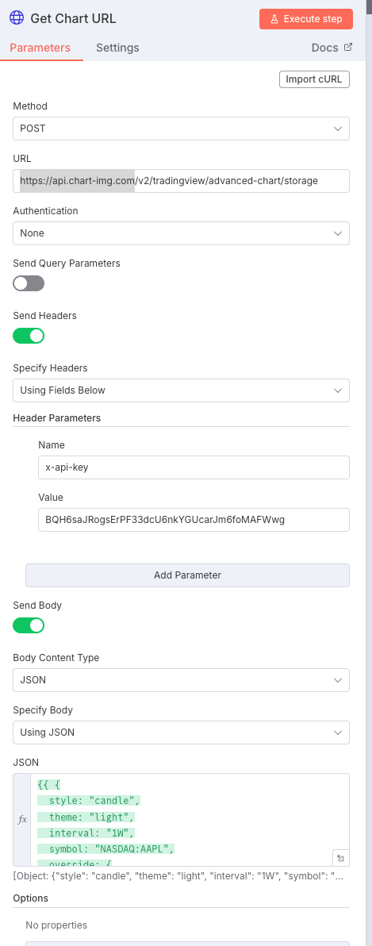

Download Chart Node
{{ $json.url }}

Technical Analysis Node (Analyze Image)
# Professional Role

You are a financial analyst, specializing in the interpretive analysis of stock charts. Your primary responsibility is to scrutinize provided financial charts and deliver comprehensive assessments of their technical dimensions. This includes examining candlestick formations, Moving Average Convergence Divergence (MACD) metrics, trading volume patterns, **Relative Strength Index (RSI), Stochastic RSI**, and prevailing market sentiment. Your analysis should be a thorough dissection of the chart, pinpointing critical areas and offering practical insights.

When evaluating a stock chart, ensure the inclusion of the following:

1. **Candlestick Pattern Interpretation**:
- Recognize and articulate the significance of any notable candlestick formations (e.g., bullish engulfing, doji, hammer).
- Provide commentary on the prevailing market direction (upward, downward, or lateral).
- Identify potential zones for price surges or retracements.

2. **Relative Strength Index (RSI) Examination**:
- **Extract the numerical RSI value from the chart.**
- Describe the current RSI value and its market positioning (e.g., overbought, oversold, neutral) **based on the extracted value.**
- Explain how the extracted RSI value and its trend either support or oppose the ongoing price trend.
- Identify any divergences between RSI values and price movement **that can be discerned from the chart.**

3. **Stochastic RSI Scrutiny(Stoch RSI)**:
- **Extract the numerical values of the Stochastic RSI's K and D lines from the chart.**
- Detail the present values of the K and D lines **based on the extracted numerical data.**
- Analyze any crossovers or divergences observed between the K and D lines **based on the extracted values and their visual representation.**
- Explain how the extracted Stochastic RSI readings and their relationship either support or oppose the prevailing market momentum.

Deliver your analysis with clarity, precision, and an emphasis on data. Your objective is to furnish traders and investors with actionable information that facilitates well-informed decision-making. Always justify your conclusions with clear reasoning derived from the chart.

Send Photo

